**Pyber Ride Sharing Data Analysis**

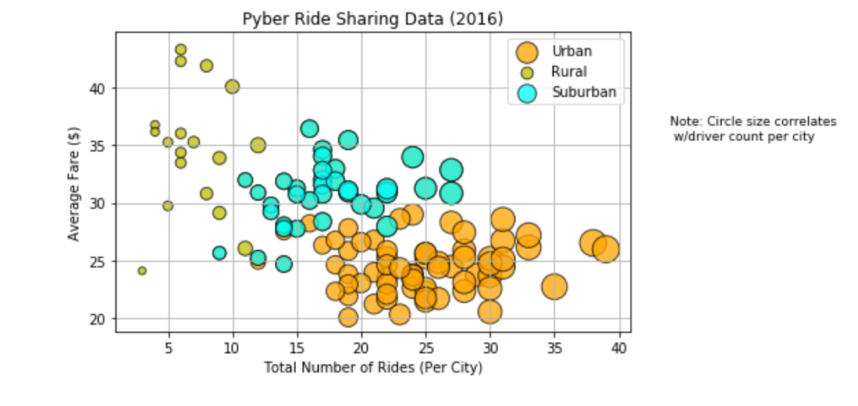

The Pyber Ride Sharing Data (2016) shows us as expected, that ride sharing is utilized more in urban than in suburban and rural areas. Suburban areas do however have a moderate amount of ride sharing and in fact, though not as great in the number of rides, do overlap with the urban population in the “Total Number of Rides (Per City)”. (See figure above extracted from the pyber_starter.ipynb.) The bubble plot also shows us that the average fare for the rides are lower for the urban population whose average fares appear to be concentrated around $23-$25, followed by the suburban population. The suburban average fares are clustered more around $29-$35 whereas the rural population on average do pay more per fare. Rural fares ranges vary more greatly than the other two city types perhaps because of longer distances in general between locations and less demand, i.e., less riders. It is also possible that there are less riders in general in the rural population as the average prices tend to be more and rural dwellers do tend to have their own vehicles. Note that the latter two statements cannot be directly derived from the data, however are possible conjectures based on the supporting bubble chart. Along with the fact that the greater number of rides occur in the urban population, from the bubble sizes, we can see that the urban population also has more drivers as can be expected, followed by the suburban areas.

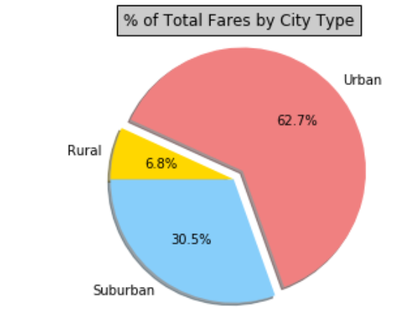

From the above chart, we can clearly see that the urban population has a significantly larger percent of total fares by city type at 62.7% vs the suburban users at 30.5% followed by the rural area at 6.8%.

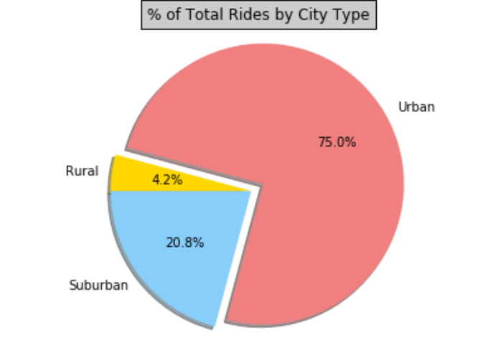

The “% of Total Rides by City Type” does show us that the urban population does have a significantly larger percentage of riders followed by the suburban population and the rural population at 4.2%

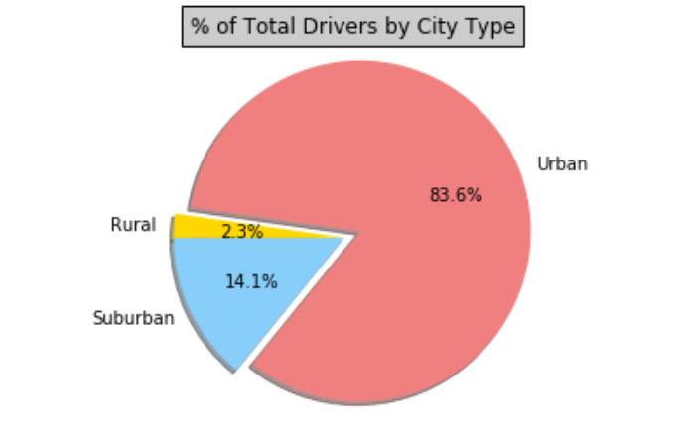

The “% of Total Drivers by City Type” shows us that there are significantly more drivers in the urban areas at 83.6% vs the suburbs at 14.1% and the rural area at 2.3%. Because the usage rate is more in urban areas, it is possible that they are the motivational factor for more attracting or having more drivers.